Project #1: Visualize

CIVE 202 -001

Written Summary

  - Date Submitted for Review: March 31st, 2026

Table of Contents
Table of Figures 2
Written Summary 3
Introduction 3
Methods 3
Variable Selection 3
Plot Construction 4
Results and Discussion: 6

Table of Figures

Figure 1- Census Region vs. Vehicle Type Bar Plot 6
Figure 2- Histogram Age Vs. Commercial Use 7
Figure 3- Boxplot of Vehicle Type by Household Size 8
Figure 4 - Speed Comparison of Vehicle Pair #10 9
Figure 5- Gap distance for Vehicle Pair #10 10
Figure 6- IDM Simulation 11

Written Summary

Introduction

The goal of this project is to create visualizations using Python to represent trends and features in the National Household Travel Survey (NHTS) and Next Generation Simulation (NGSIM) datasets. These visualizations will provide insights into real-world traffic behavior and driver dynamics. The Federal Highway Administration (FHWA) conducts research into analyzing roadway operations and driver safety, and they are the source for the NHTS and NGSIM datasets. The NHTS data will be visualized for high-level analysis for vehicle types by census region, vehicle age by commercial and non-commercial use, and vehicle type by household size to represent trends graphically.

The NGSIM data will be grouped and organized to plot visualizations of specific vehicle pairs for detailed analysis to analyze follower dynamics and trends. After the real-world trajectory pairs are graphed, Python will be used to calculate and simulate the follower trajectory information with established parameters in the Intelligent Driver Model (IDM) for comparison and analysis with the real-world counterpart in the data.

Methods

Variable Selection

The variables that were selected from the NHTS dataset were chosen because they represent driver household information, geographic location, and vehicle information that can be used to identify trends and behavior on a national level. The census region and Vehicle type visualized give a representation of what type of vehicles are most used in their various region and at what rate. The age of commercial and non-commercial vehicles was plotted to identify trends in the life span of commercial vehicles on the road compared to non-commercial vehicles. Then, a representation of Household members by vehicle type is plotted to identify any trends that relate the size of the household and the type of vehicle they utilize.

In the NGSIM dataset, variables were selected that detail finite vehicle movement information, permitting a follower car analysis and simulation. The trajectory number is the variable that links the individual leader and follower pair for comparison and analysis. The leader and follower position, speed, and acceleration variables were selected because they describe what is going on at a micro level in the data set. The time variable was selected because it is necessary for the time-series analysis graphs and analysis. The gap distance variable was not originally found directly in the data set, but it was calculated in Python using the leader and follower position variables for specific vehicle pairs.

Plot Construction

Census Region vs. Vehicle Type

The data for the Stacked bar chart for the Census Region vs. Vehicle Type was grouped by census region and vehicle type and was cleaned of missing values in these variables. Pandas was used to read the information from the NHTS CSV file and import it into Python. Seaborn was then used to plot the information with color indicators in the bars to identify the vehicle type.

Vehicle Age by Commercial Use

Pandas was again used to import the information for the variables of Vehicle age and Commercial use. A histogram works well if the y-axis variable is numerical in nature, and the other variable is a yes/no variable. The purpose of this graph is to compare the age distributions of commercial and non-commercial vehicles.

Household Size by Vehicle Type

Pandas was again used to import and clean the variables of household size and vehicle type so it can be plotted as a boxplot to visualize the trends and behaviors of households nationwide. This plot was chosen to identify household demographic patterns as they pertain to vehicle type and how they are related to the size of the household.

Leader vs. Follower Speed

The variables of leader speed, follower speed, and time were imported and cleaned for missing values using Pandas. These variables were then organized and filtered by Trajectory pair #10 so an individual vehicle pair could be plotted. These variables were plotted as two line plots in the same graph, with the y-axis representing speed and the x-axis representing time. These variables, when compared together as separate line plots, allow the traffic event and reaction to be analyzed.

Gap Distance Over Time

With the variables already imported and cleaned, a new variable called gap distance was created by calculating the distance between the leader vehicle and the follower vehicle at individual time increments. This gap distance was then plotted as a line graph to represent the distance between the vehicle pair that can be used to analyze the following distance and compare it to the Leader vs. Follower Speed graph for interpretation and analysis.

IDM Simulation

The IDM simulation variables include the same real-world variables that were used in the Leader vs Follower Speed plot, but include a simulated follower vehicle. This simulated follower vehicle simulation was created by using the IDM Equations.
$\frac{dv}{dt}=a[1-{\left(\frac{v}{v_{ο}}\right)}^{δ}-({\frac{s^{*}(v,Δv)}{s})}^{2}$]

$$s^{*}(v, Δv) = s₀ + v·T +(\frac{\left(v·Δv\right)}{\left(2\sqrt{a·b}\right)})$$

These equations were used in defining a function that calculated the acceleration of the simulated vehicle based on the position, speed, and acceleration of the real-world leader vehicle in the trajectory pair. The simulated model was then plotted on the Leader vs. Follower Speed plot for comparison with the actual follower vehicle and to evaluate the realism of the model.

Results and Discussion:

Census Region vs. Vehicle Type

Across all regions, automobiles and station wagons are represented as the most widely used vehicles. There is a common correlation that in each geographic area, there are more SUVs than pickup trucks in use. The Northeast region has significantly fewer vehicles overall, and this may be because that area has denser urban areas and public transportation than the other geographic areas. These regional distinctions in vehicle type usage are important because they influence long-term transportation planning and development. The FHWA can take these vehicle type distributions into consideration when trying to anticipate future infrastructure needs and governing policies that reflect the unique nature of each geographic region.

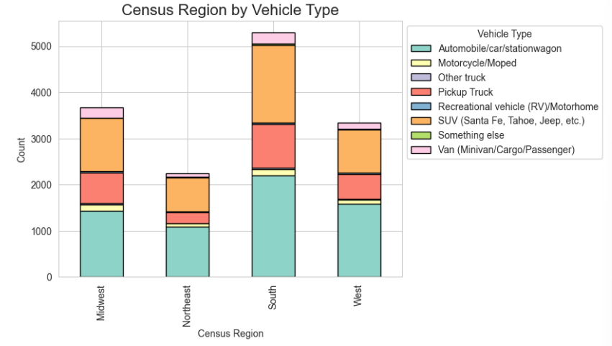
Figure 1- Census Region vs. Vehicle Type Bar Plot

Vehicle Age by Commercial Use

For the histogram comparing vehicle age for commercial and non-commercial vehicles, both categories have a strong concentration of vehicles under ten years old. After this ten-year mark for age, the number of commercial vehicles in use has a significant drop and then a gradual decline. The non-commercial fleet is significantly larger when compared to the commercial fleet, which is expected, given the far greater number of non-commercial vehicles in use. This concentration of commercial vehicles under the ten-year mark may be explained by their frequent high use for transportation, contributing to higher vehicle mileage and maintenance, leading to the users updating their fleet more frequently than personal drivers need to. This plot helps analyze the turnover rate for commercial vehicles and how that relates to environmental impact and safety programs for commercial vehicles on the roads. Understanding these trends at a macro level can help better plan and anticipate trends related to commercial vehicle use.

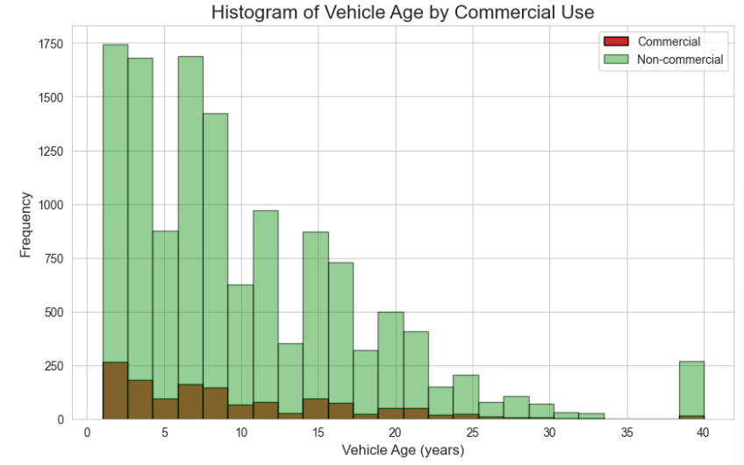
Figure 2- Histogram Age Vs. Commercial Use

Vehicle Type by Household Size

The box plot graphing vehicle type by household size gives insight into how household size influences the type of vehicle usage patterns. The distribution shows that larger families tend to gravitate towards using vans or trucks in order to meet the needs of transporting the extra numbers. This aligns with practical needs in larger family sizes, requiring larger vehicles for transportation. The median value for SUVs is lower than originally expected for household size, but this value may be influenced by some of the SUVs in this variable, which only have 5 seats. These findings are significant because household size contributes to vehicle demand and influences vehicle fleet composition, roadway design, and traffic volume. Understanding these demographic trends that influence vehicle selection helps planners anticipate future behavior.

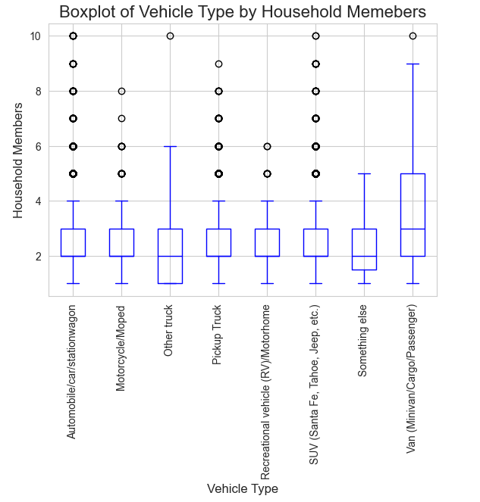
Figure 3- Boxplot of Vehicle Type by Household Size

Leader vs. Follower Speed

This dataset for trajectory pair #10 was graphed to show a comparison of the speed (in m/s) of the leader and follower over a 45-second interval. Both vehicles decelerate over the course of the first 10 seconds and then maintain a relatively constant speed of less than 2 m/s until the 25-second mark, when they both start gaining speed again at a higher rate, with the leader vehicle being about five seconds in the lead. With the starting and ending speeds of each vehicle in the 10-14 m/s range, this may indicate that there was traffic congestion or a tight turn at the midway point of this time interval that necessitated the need for both vehicles to decelerate and then accelerate after clearing the chokepoint. The line of the leader car also has smoother changes in speed than the follower car, which may indicate that the follower car must account for the leader car's speed in its own acceleration and deceleration. The dashed yellow line represents 12 m/s or 27mph, which is shown to provide a reference point that shows that both these vehicles fall well below typical roadway speeds during this period.

These patterns in driver behavior and dynamics are studied by the transportation industry because they detail and demonstrate real-world behaviors. These behaviors indicate reaction delays, speed adaptation, and flow of traffic that can be used to determine how small instances of traffic affect the overall pattern of traffic on roadways.

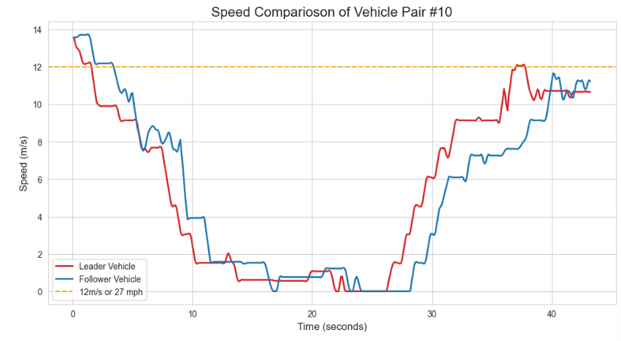
Figure 4 - Speed Comparison of Vehicle Pair #10

Gap Distance Over Time

In the gap distance over timeline plot, the same trajectory pair was reused from the leader vs follower speed plot. This graph represents the distance between the vehicle pair when they decelerated after the start, coming less than 5 meters from each other, at about the halfway point. Then the gap distance increases at a significant rate, which correlates with the speed of the leader vehicle increasing at a higher rate than the follower vehicle. This highlights the dynamic nature of traffic flow behavior and the challenges drivers face when regulating speed and distance from other vehicles. Understanding how drivers react and adjust speeds in traffic conditions is relevant in designing infrastructure and designing vehicle following simulations, such as the next plot.

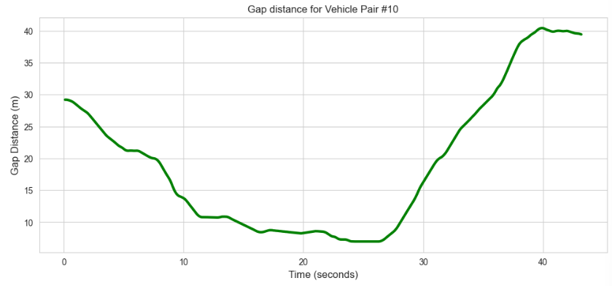
Figure 5- Gap distance for Vehicle Pair #10

IDM Simulation

The IDM simulation plots the simulated follower vehicle and its relation to the speeds over time for the leader and follower vehicles. The simulated vehicle generally follows the actual follower's speed and position with smoother transitions. However, this simulated follower vehicle is unable to keep pace with the actual follower vehicle's steep reductions in speed because it is limited to a comfortable braking deceleration of 1.5 m/s^2. This limitation shows that the IDM simulated follower has difficulty with abrupt changes in speed or acceleration that are commonplace in the real world. For the transportation industry, these findings are significant because of the increasing demand for systems of study and self-driving vehicles that have increased in numbers across the nation.

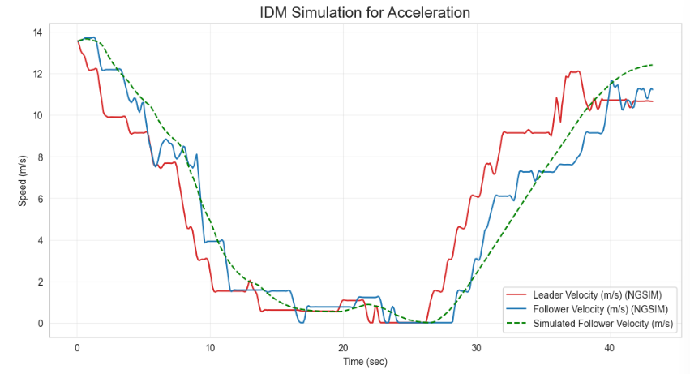
Figure 6- IDM Simulation

